**The mafia game project.**

Disclaimer: this project is currently unfinished although it has a fully playeble in-console game,

It was slightly more ambitious than I originally thought and despite the effort the time wasn’t quiet enough.

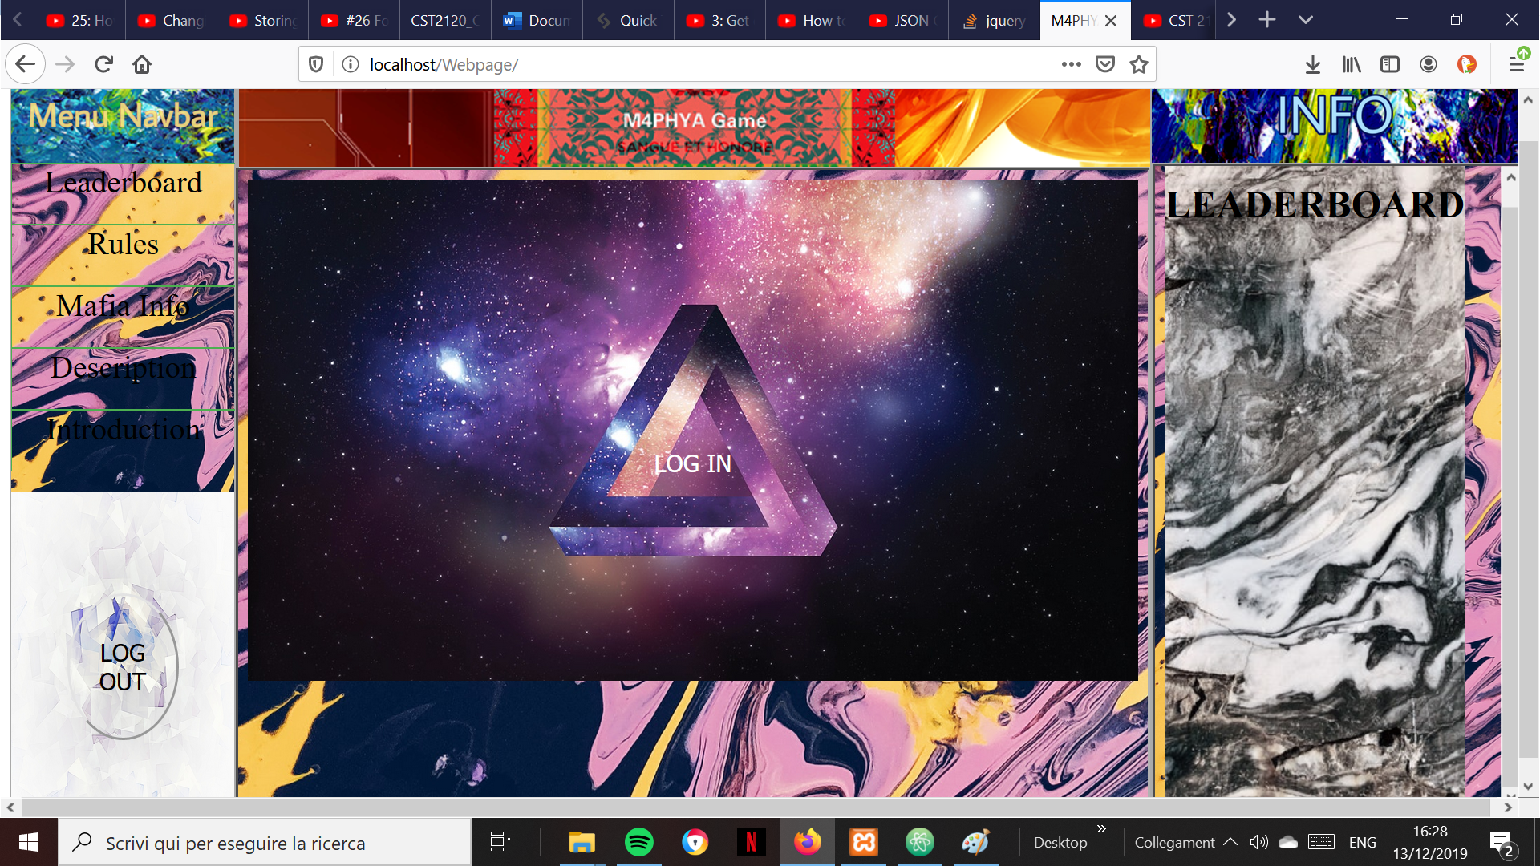

When the user is in this page, he’ll be able to browse through general information, such rules and information about NPCs thanks to the NAV Bar

But most importantly, the user can get right into the login page through the big LOG IN button

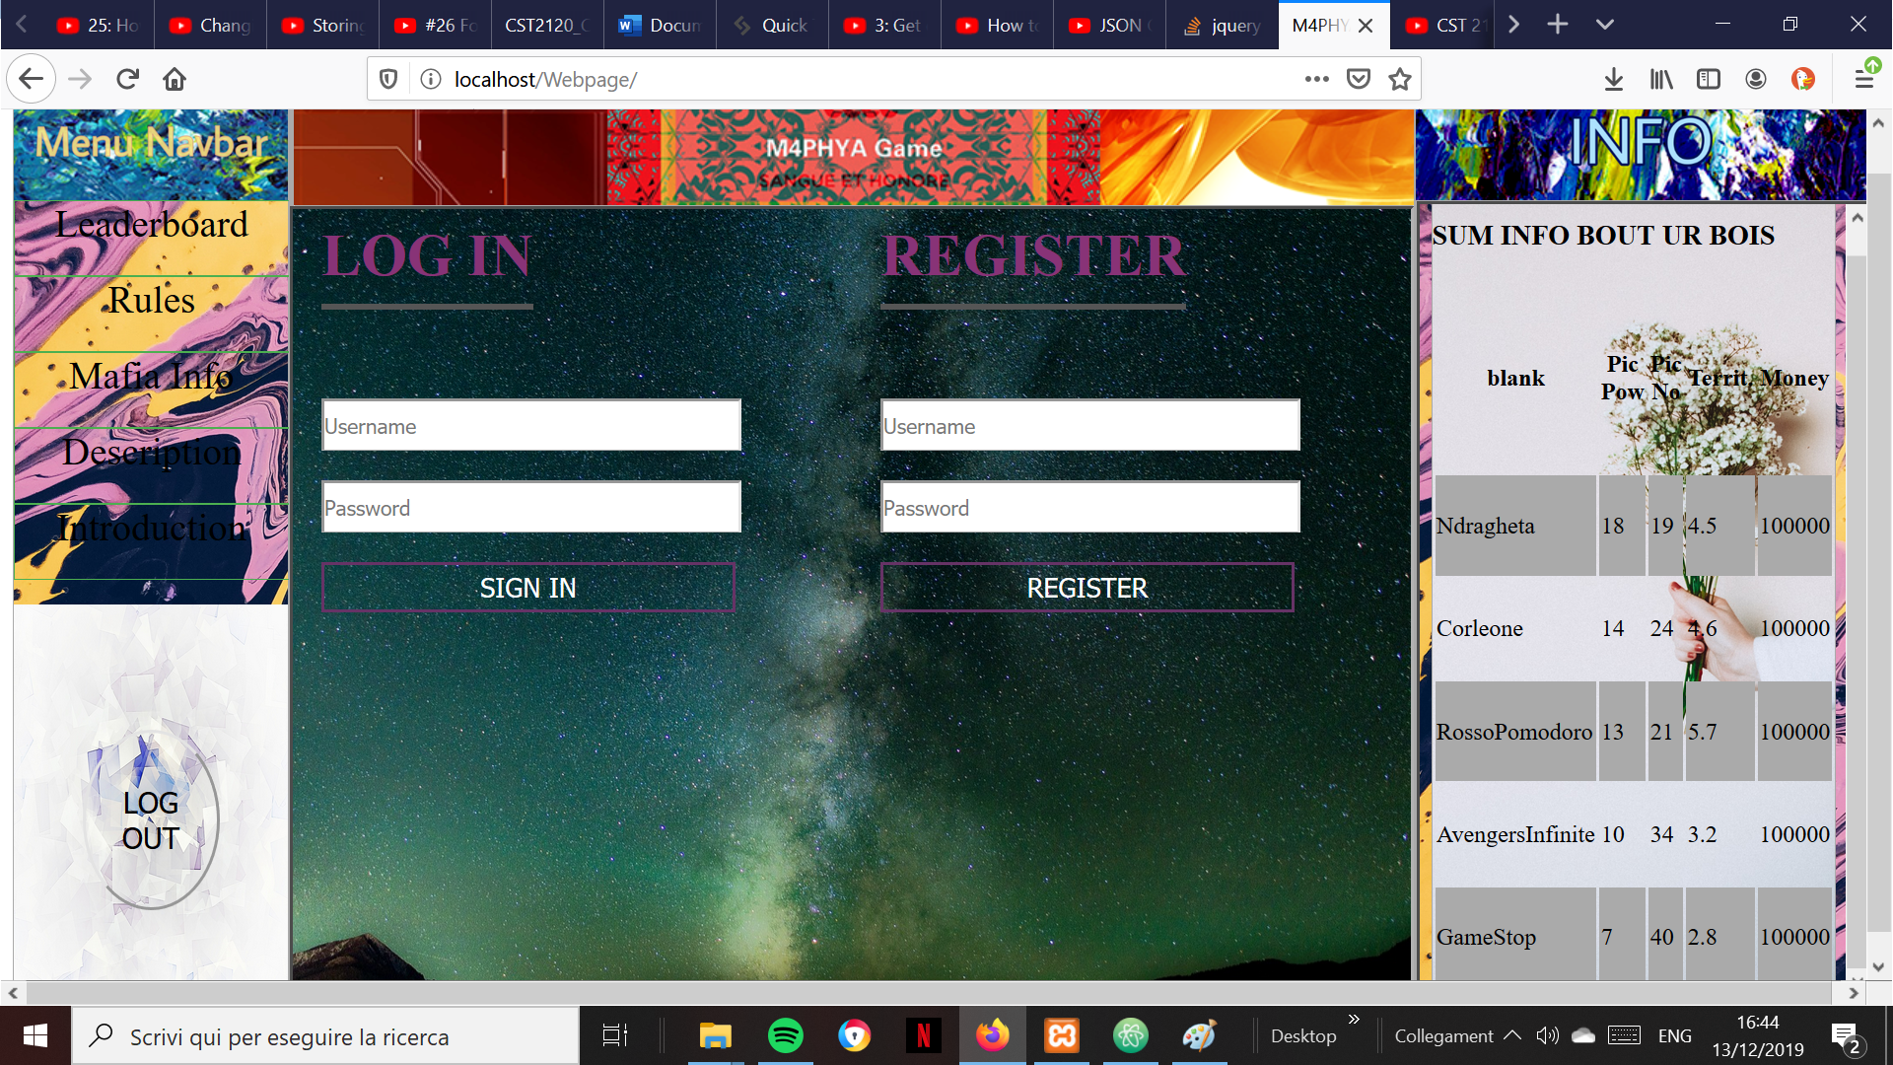Once in the login page the user can either choose to attempt the login using a valid Username and Password or to register under a new Username, which then will be used to check if that username exists in the local storage.

A simple regular expression has been used to check if the inserted credentials are coherent with the made up rules about username and password, which requiers the user to input between 3 and 12 characters where only letters and numbers are accepted, a js function also checks whether the the Username exists or not, and then if its a login it also checks if the inserted passwords equals to the once associated with the username input.

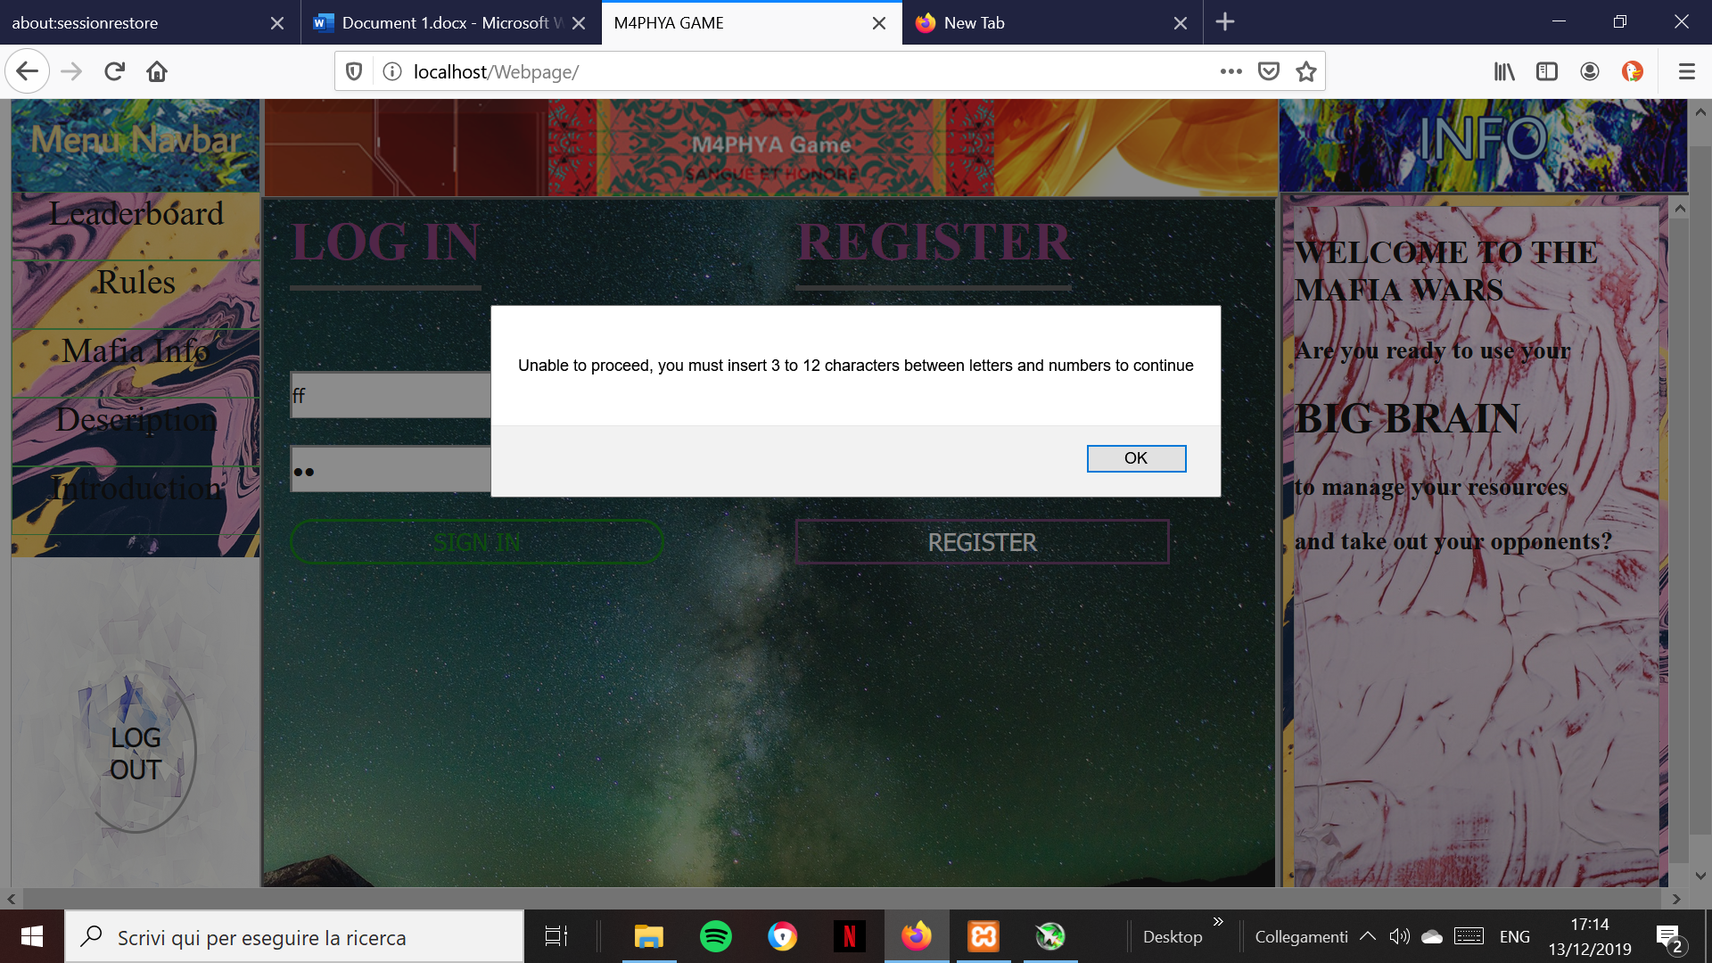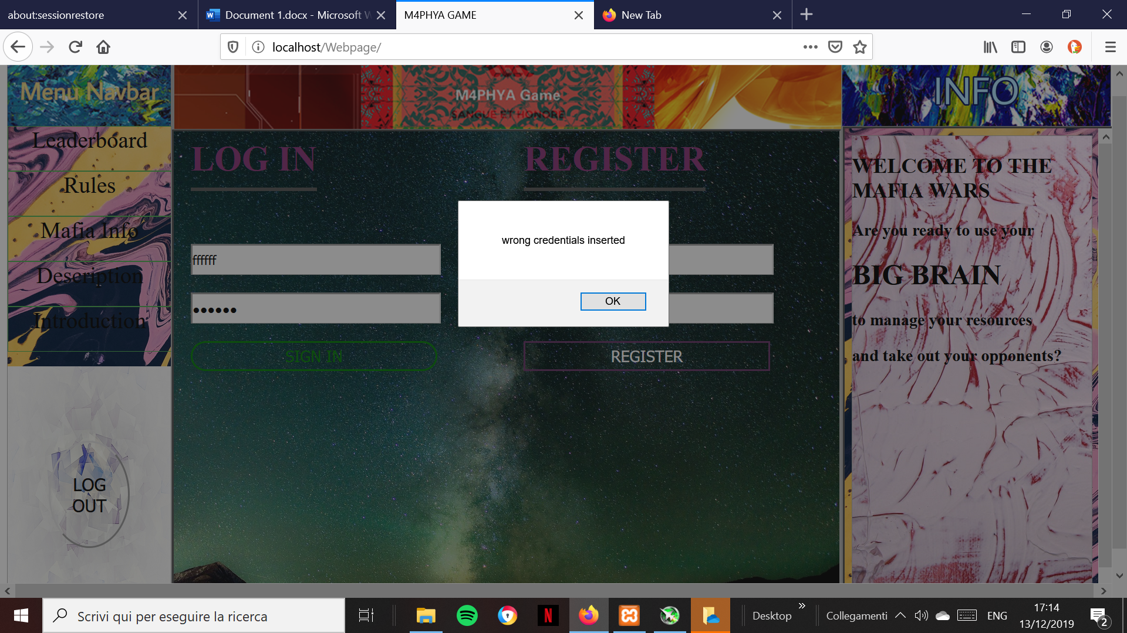And the registration form also tell the user if the chosen username is already taken or not

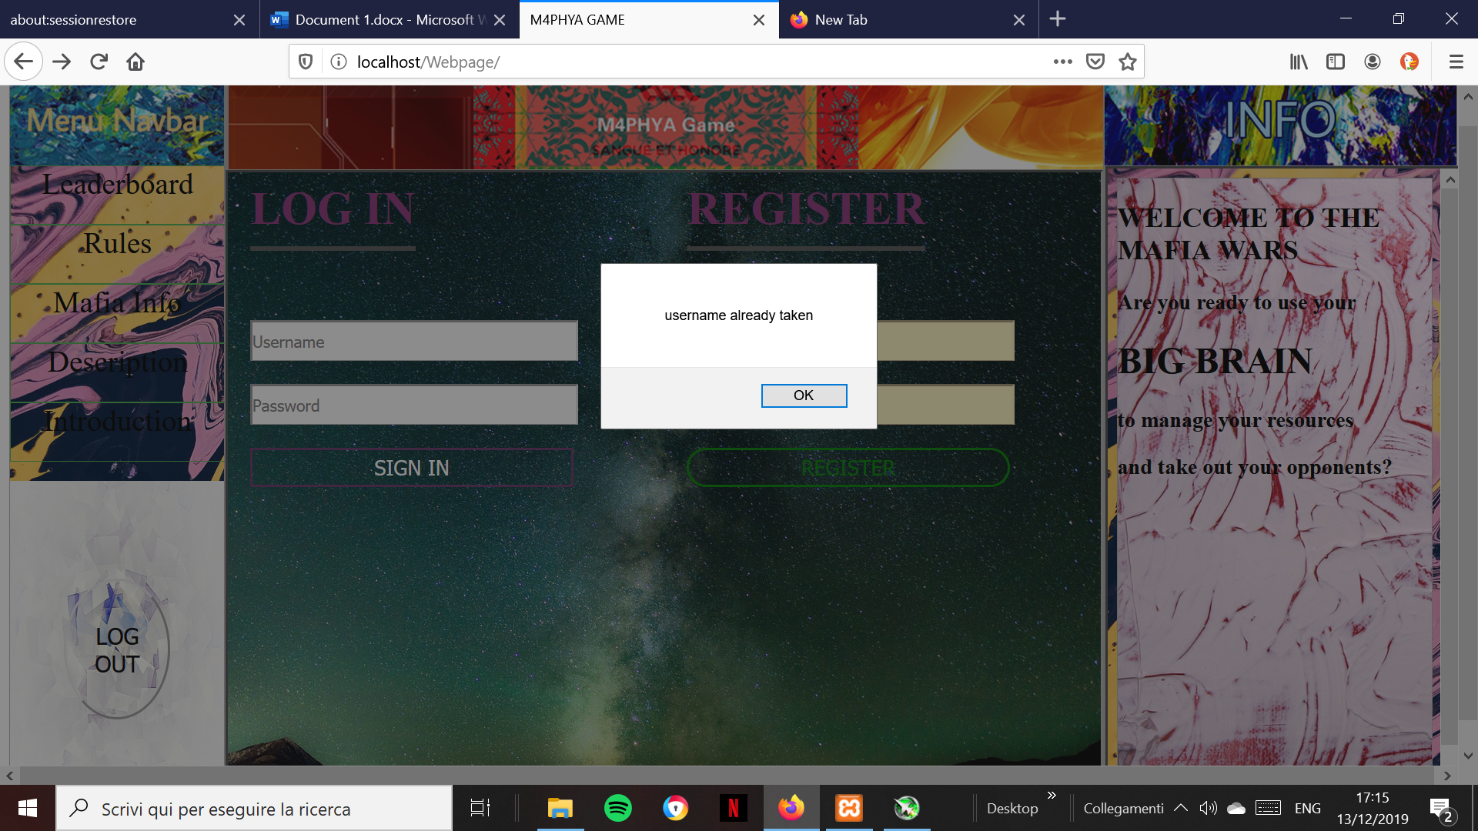The login page generates two objects, which both store the same data, but one of them will be overwritten; the one overwritten is a collection of data of the user that is logged in in that specific moment, which will allow the website to process its data more easily  
The one not overwritten is being kept in the local storage  
whereas the other one will become useless once user clicks on the ”Log out” button on the bottom-left

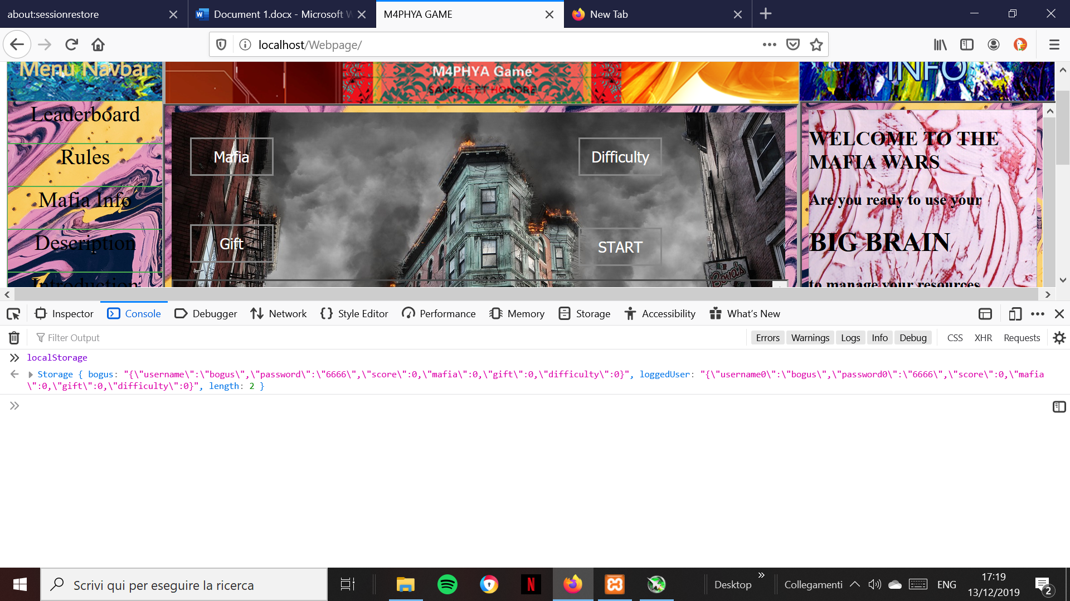Currently in the local storage, for each user, is being stored(a part from username and password): the faction that the user will choose, the difficulty ,the initial bonus; such data will be part of the game, implemented in the mechanics and the difficulty affects the score(which is being stored among the other data)

In the settings page the user will be able to personalize their experience through some options which are: the faction the they will control, the difficulty and the initial bonus

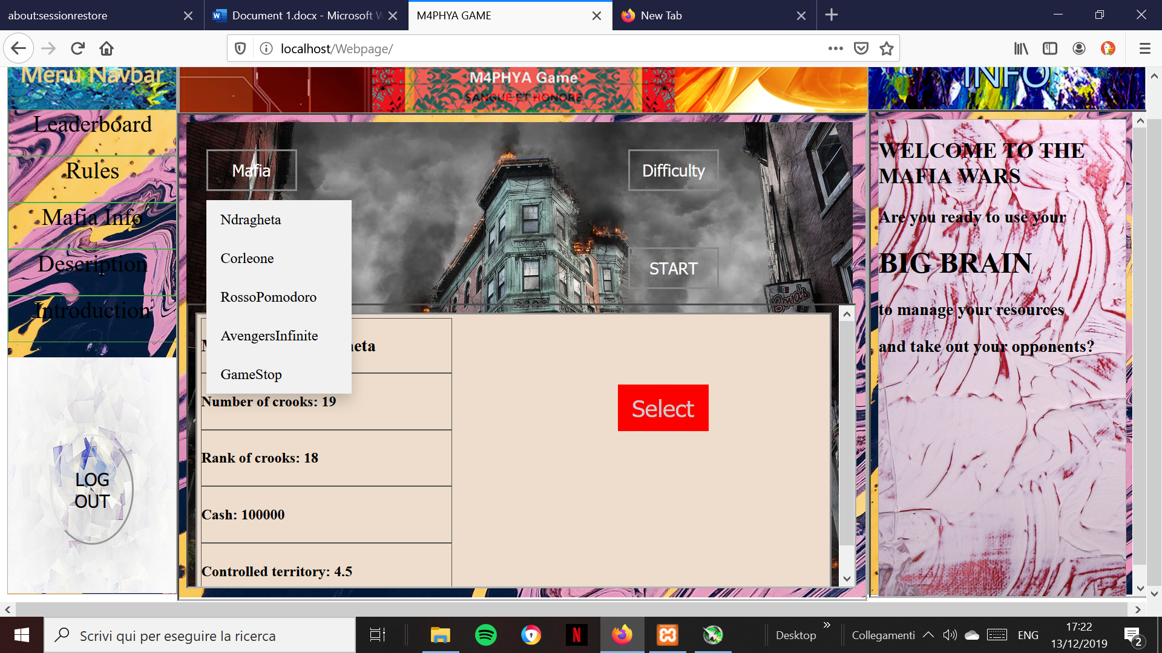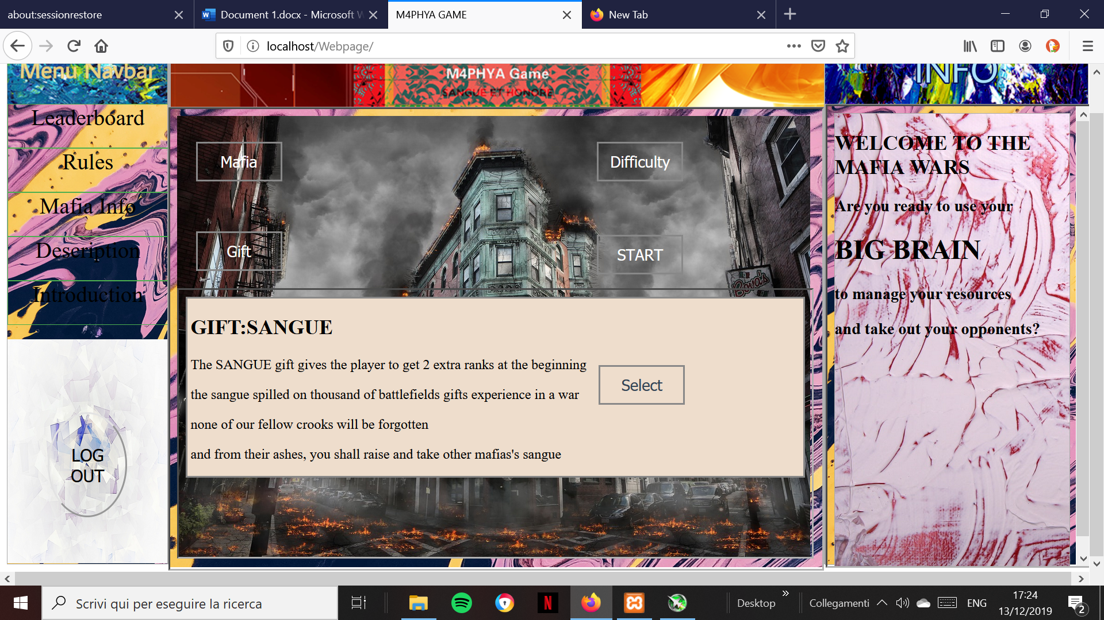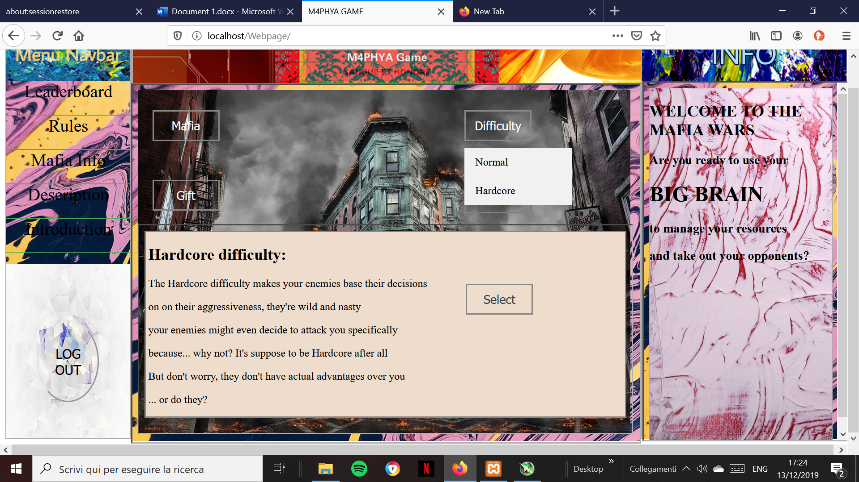Once they select one option for each dropdown menu, they will be able to progress through the webpage, otherwise they will get an alert message

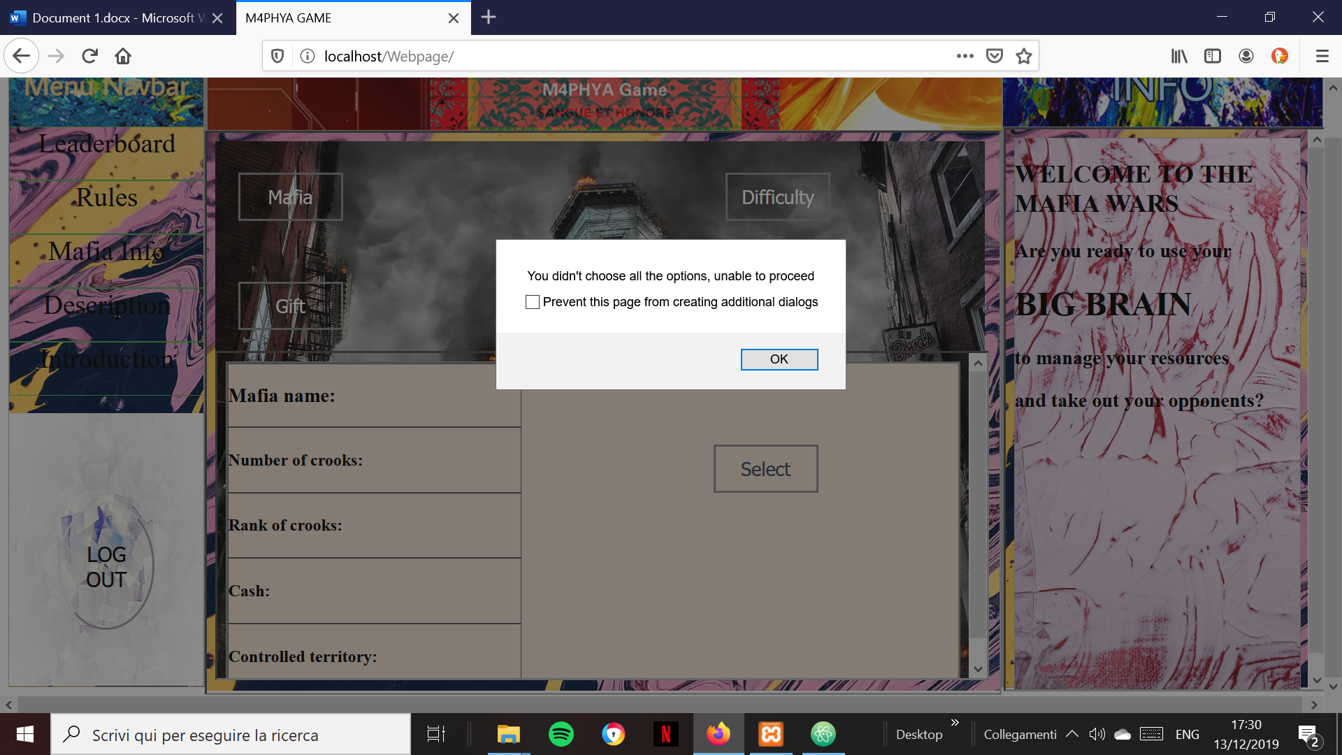Once the user gets to the game page, he’ll see their information on the bottm-left

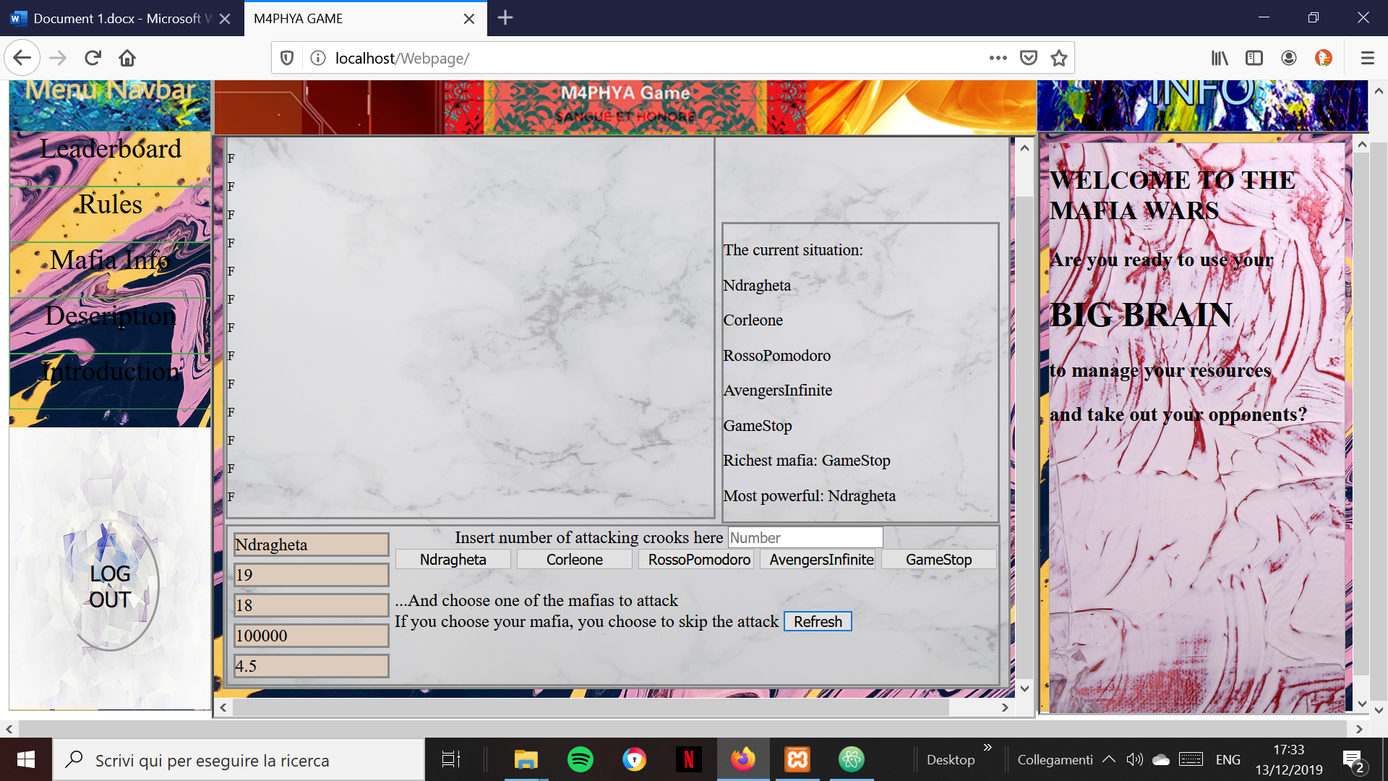They will also see the enemy factions on the top-right

They will be able to send a chosen amount of units against those factions by choosing the amount and submitting through one of the buttons that represent the enemies  
If they choose their own faction they willingly choose to skip the attack  
The graphic part doesn’t work, I couldn’t manage to find a way to refresh the values in time  
But every action is being output-ed through the consol.log

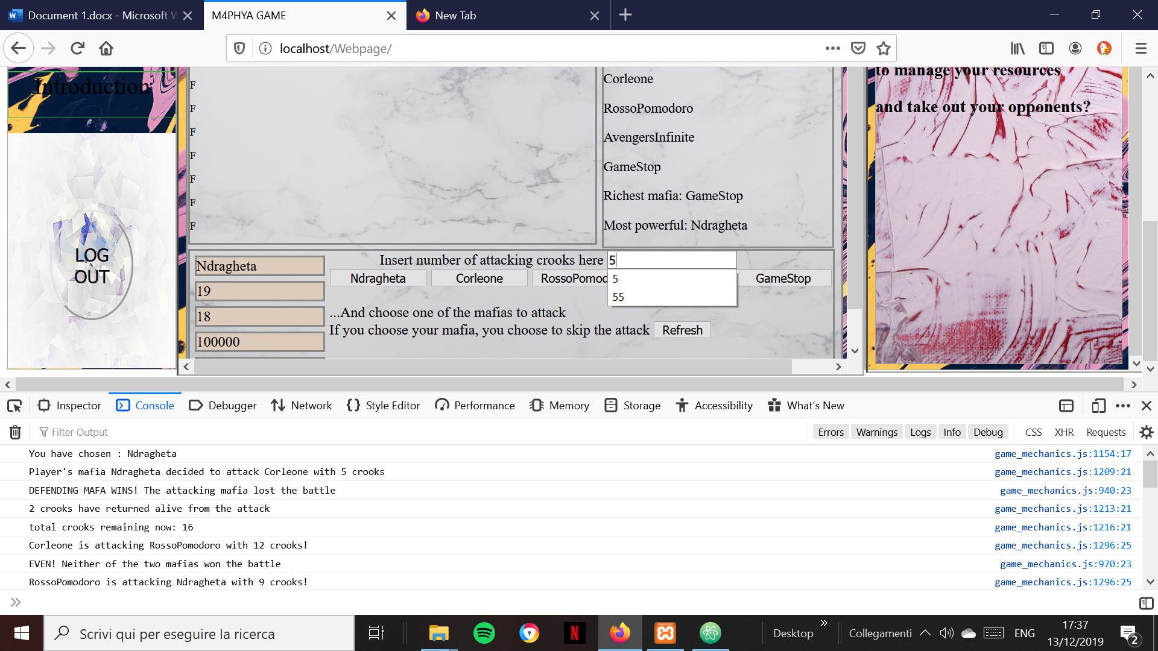***RULES and GAME functionality:***

***T***he game idea is pretty simple: factions with various attributes that send against each other an amount of units in order to defeat the others and get as much power, cash and territory as possible  
The game is RNG based, almost every aspect of it is driven by a defined range of randomness  
It might sound simple but there are expressions and calculation behind every scenario and based on the scenario the range of random numbers changes in favor of the winner or the ones that apply some strategy  
  
Every turn is counted as a year  
And every year all the factions are able to perform an attack, which outcome is based on luck  
All the attributes of a faction grow by interest and actions after every attack following different formulas, for example: the territory gained is based on how many units are being used in an attack  
Units will grow based on the territory  
The rank of each unit will grow based on the attacks sent and recieved  
Both rank and units will be part of the overall power which will be used in a formula to calculate how many units every defending faction will use to respond to an attack, in such way that they will always try to send an amount of units of which power is as similar as possible to the attacking units  
If a faction doesn’t have enough units to respond to an attack, it will have a high risk of being taken out, which means a lot of bonuses for the faction that eliminates it  
Money are being drained by the units and their ranks, so a faction that plays too defensively and doesn’t gain enough territory will not have enough money to pay its units, which would mean that it’s being eliminated.  
There are few information that can help the player to choose their actions, like the outcomes of other factions’s attacks and being able to know how has more money or power  
  
Leaderboard:

The leaderboard is clearly not working, but I tried using arrays and functions that retrieve information from the local storage